Welcome to Kindergarten

Mr. Mitchell

**Social Studies Learning Goals**

* Producers & Consumers
* Wants and Needs
* Historical Figures

**Science Learning Goals**

* Weather & Seasons
* Plants & Animals
* 5 Senses

**Art**

We will work to develop confidence and experience joy through creative expression.

**Physical Education**

We will work to develop knowledge and understanding, attitudes and behaviors, and skills that will enable each student to develop a lifestyle in which regular vigorous physical activity is practiced.

**Language Arts Learning Goals**

* Sight Words
* Reading Fluency & Comprehension
* Vowels/Blends
* Sentence Writing
* Nouns, Verbs, Pronouns, Adjectives
* Types of Sentences
* Writing (Narratives, Opinion, Informational)

**Math Learning Goals**

* Counting to 120
* Graphs
* Addition and Subtraction
* Place Value
* Shapes (Plane and Solid)
* Word Problems
* Comparing and Ordering Numbers
* Time (Hour/Half Hour)
* Measurement (Standard)

**Our Learning Environment**

This year we will be operating a little different than we’re accustomed to, but we will continue to have fun while learning. Students will spend time working independently, with a small group of children, or one-on-one with the teacher.

**Synchronous and Asynchronous**

**Synchronous** teaching allows the teacher(s) and students to **gather in real time using a virtual online** meeting tool such as Microsoft Teams in order to engage, review, and discuss material and assignments.

**Asynchronous** learning allows students to learn the same material at different times and locations- **that is not being delivered in person or in real time.**

Students are expected to complete synchronous (virtual) and asynchronous (non-virtual) assignments.

**Visitors**

**(at the school)**

Visitors **must** present their picture ID in order to enter the building. Upon entry, you must **sign in and out** at the Front Office.

**Communication**

I will be communicating with parents via ClassDojo. Passwords will be given out the first week of class. Please check ClassDojo regularly for pertinent information. I am available during office hours and on Fridays for conferences.

**Online Expectations**

* Be on time
* Make sure your parent/guardian is near
* Be prepared with supplies
* Wear school clothes
* Make sure your camera is on
* Make sure mute is on
* No eating
* Find a quiet spot free from distractions
* Listen
* Raise your hand
* Be kind

**Contact Information**

**Office:** 762-218-3489

During my Planning Period from 8:00-8:50am

**Email Address:** [**mitchdi@richmond.k12.ga.us**](mailto:mitchdi@richmond.k12.ga.us)

**Grades/Assessments**

We will be using a Standards-based progress report/report card (1, 2, 3, 4). To be On Grade Level students must obtain a 3. Your child will receive grades based on their online work and test grades. Students will receive a weekly grade in all content areas, to include Math, Reading, Writing, Phonics skill, Science, Social Studies, Art, and PE assessment. Grammar assessments will be given as we complete units and/or topics.

**Schedule**

(Tentative)

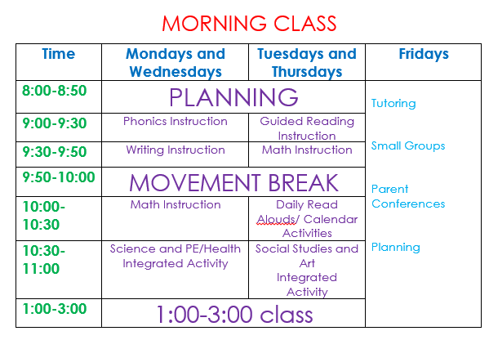

.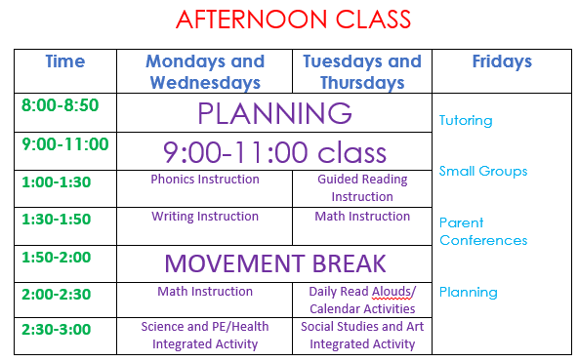

**Conduct Grades**

Students are expected to behave appropriately at all times.

100 – Great Day!

90 – Received 1 infraction

80 – Received 2 infractions

70 – Received 3 infractions

60 - Received 4 infractions

50 – Received 5 infractions